**GLAMOUR TCP PEDESTAL FANS:**

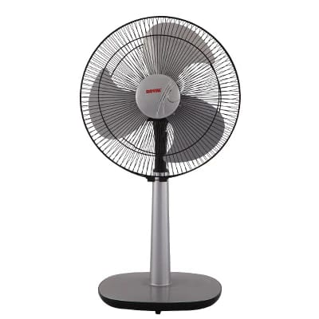

**Price: 10,295.00**

Glamour TCP Fans are a stunning blend of style and functionality, elevating any space with their sleek and modern design. These fans boast a robust build quality, ensuring durability and reliability. With their powerful motors and aerodynamically designed blades, Glamour TCP Fans provide efficient air circulation, keeping you cool and comfortable. Their adjustable tilt and oscillation features allow for customizable airflow, making them perfect for homes, offices, and commercial spaces seeking a touch of elegance and sophistication.

**Key features of glamour tcp pedestal fans include:**

* **Adjustable Height:** Allows customization of fan height for optimal airflow.
* **Oscillation Function:** Provides widespread cooling by oscillating across a larger area.
* **Multiple Speed Settings:** Offers different speed options (low, medium, high) for varied airflow control.
* **Sturdy Build:** Designed with durable materials to ensure long-lasting performance.
* **Tilt Function:** Adjustable tilt to direct airflow up or down for better air distribution.
* **Quiet Operation:** Engineered for quieter functioning for minimal noise while cooling.
* **Energy Efficient:** Consumes less electricity, providing cooling with reduced power usage.